Finished Code and Diagrams

**Diagrams shown in the course are available in this repo:**

<https://github.com/StephenGrider/DockerCasts/tree/master/diagrams>

Clone down the entire Github repo to your computer. Go to [draw.io](http://draw.io/), then choose "Open Existing Diagram" and use the file explorer to open a diagram file from your computer.

**Finished project code is now attached as a downloadable zip file to applicable lectures or as checkpoints throughout the course.**

Join Our Community!

We welcome you to join our Discord community of fellow students, developers, and engineers. Keep up with the latest news and announcements or start a discussion [by clicking here](https://discord.gg/anZw2cXH2G)!

Installing Docker for Windows Home users

**updated 4-14-2020**

If you are a Windows Home user, you will not be able install the Docker for Windows Desktop edition, as it requires Hyper-V virtualization. This is supported only by Windows Professional and Enterprise editions.

**Windows Home users will need to install Docker Toolbox**which uses VirtualBox instead.

Docs and setup info available here:  
<https://docs.docker.com/toolbox/toolbox_install_windows/>

Release downloads available here:  
<https://github.com/docker/toolbox/releases>

Toolbox will install everything you need including VirtualBox.

You may also need to enable virtualization in your computer's BIOS settings. This will be different for each manufacturer, please refer to their documentation on which keys to use to access these settings on reboot.

After Toolbox is finished installing, open the Docker Quickstart Terminal. This will complete the setup and provision your VirtualBox machine.

**Check your install:**

Launch the Docker QuickStart terminal and type the command:

docker run hello-world

This should pull down the test container and print hello-world to your screen.

**\*Note\***

A major difference between the course lecture using Docker Desktop vs. Docker Toolbox is that you will not be able to use localhost anymore. Instead, we will need to use the IP address returned by running docker-machine ip

Very commonly this is **192.168.99.100,**but for you, it could be slightly different.

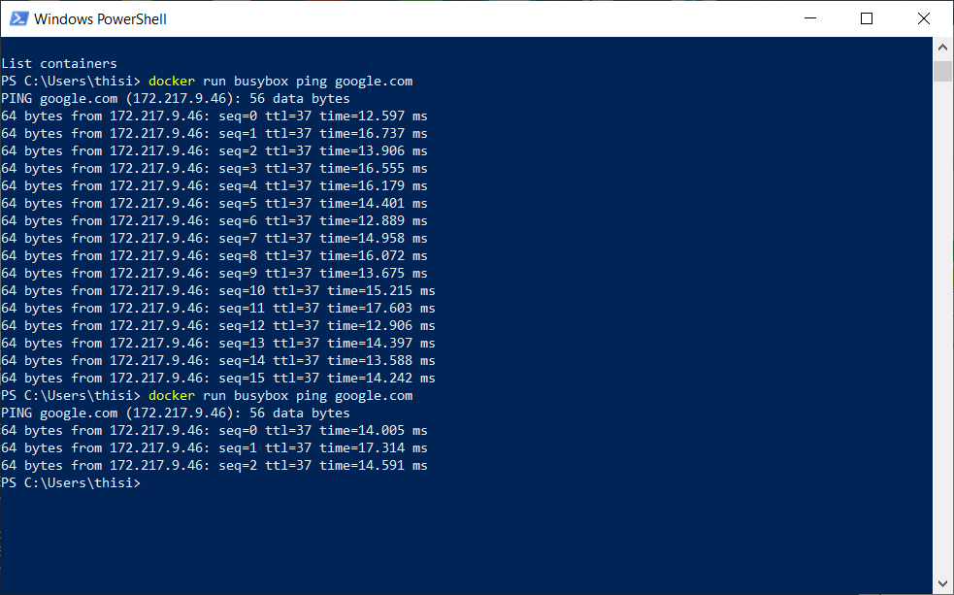

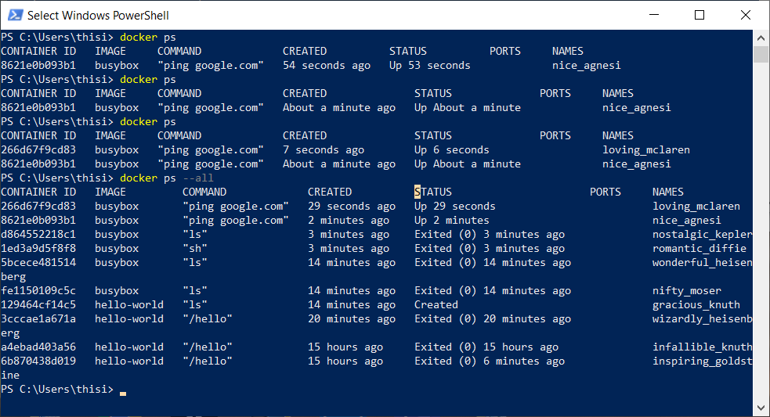

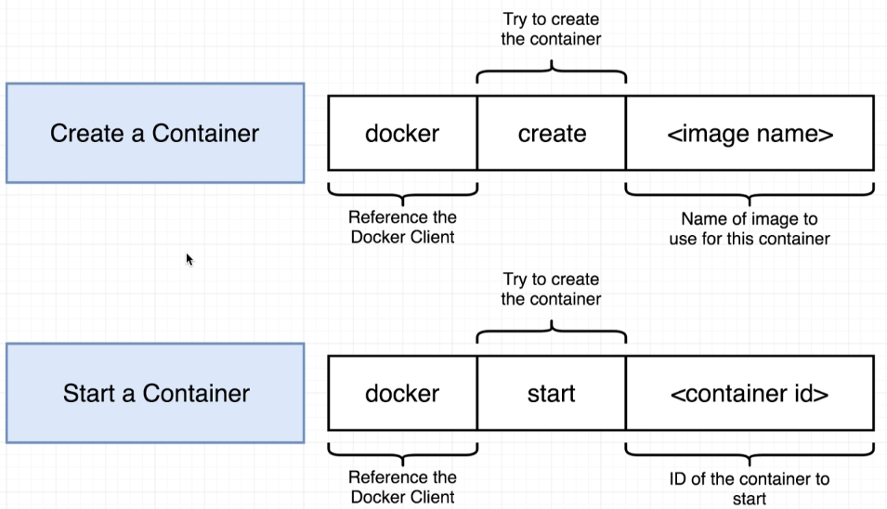

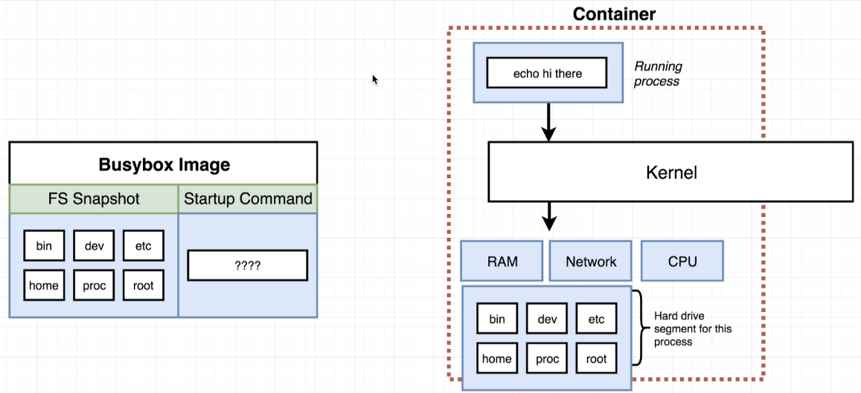

Docker system prune #deletes completely the container

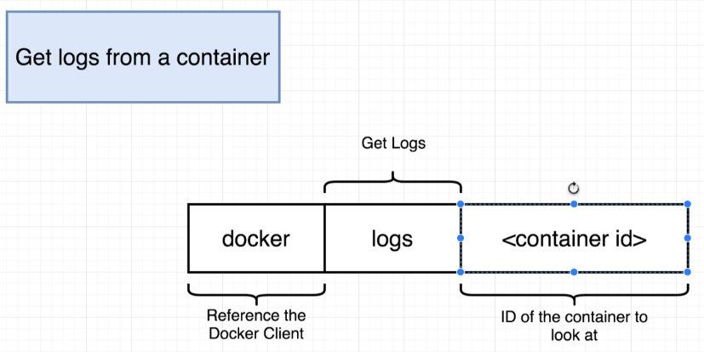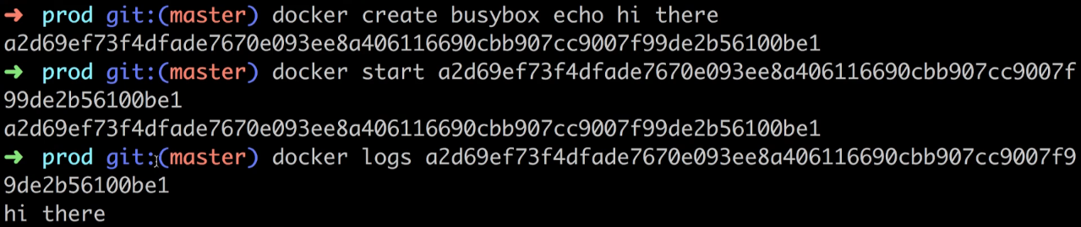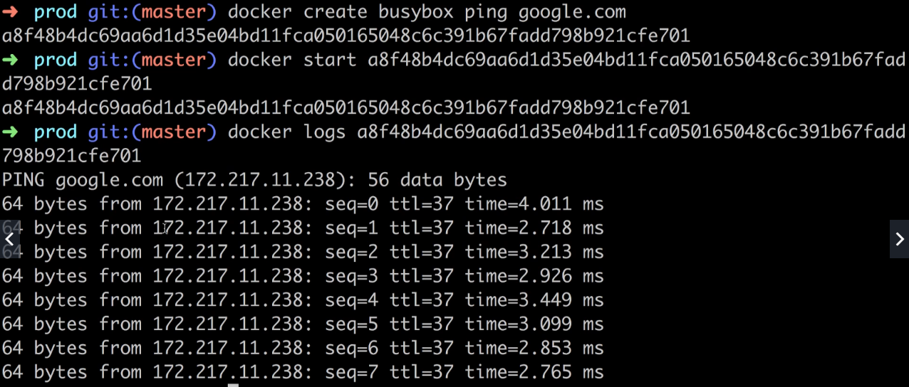

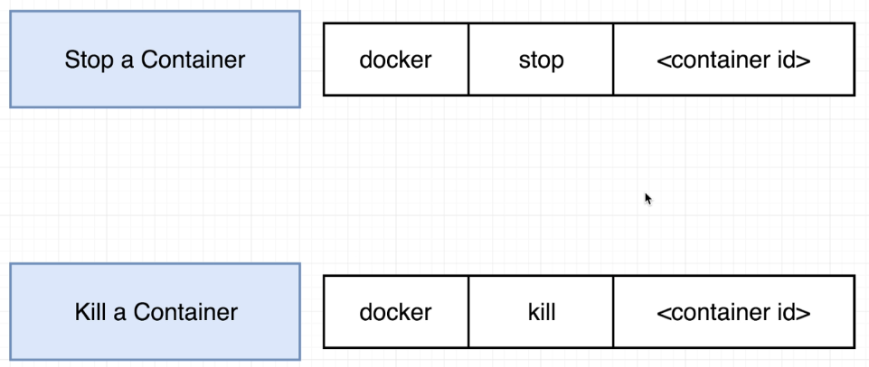

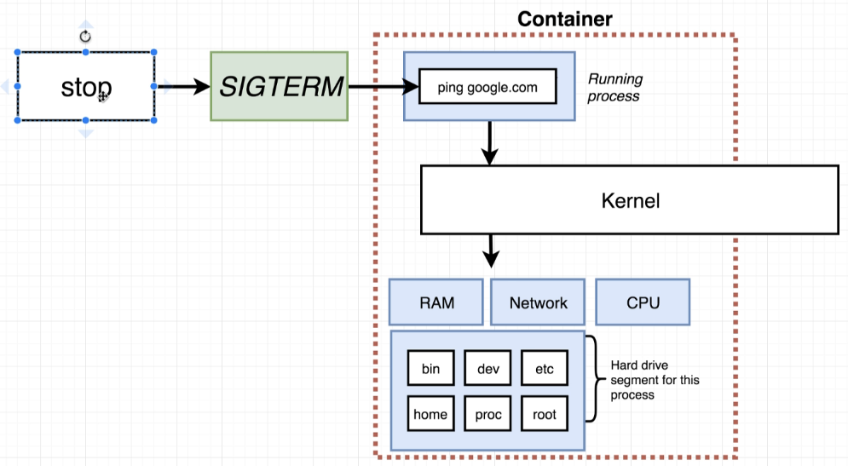

Stop gives some time 10Seconds

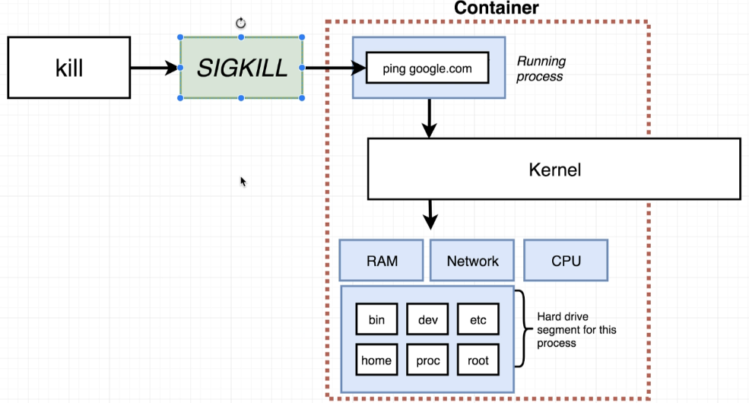

Kill stops promptly

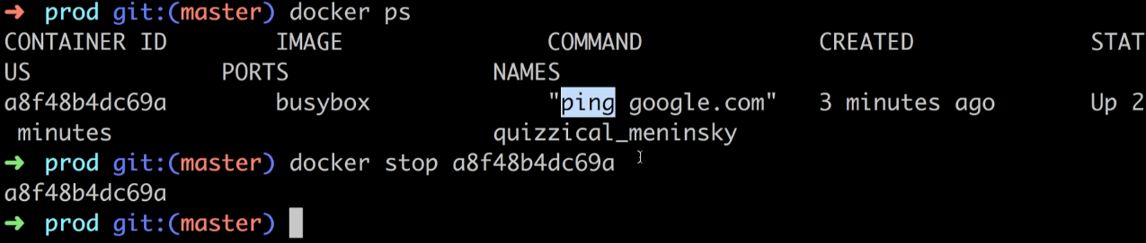

docker run -it ubuntu /bin/bash

<https://kb.objectrocket.com/redis/how-to-install-redis-on-ubuntu-using-docker-505>

redis-server

PS C:\WINDOWS\system32> **docker run -it ubuntu /bin/bash**

Unable to find image 'ubuntu:latest' locally

latest: Pulling from library/ubuntu

83ee3a23efb7: Pull complete

db98fc6f11f0: Pull complete

f611acd52c6c: Pull complete

Digest: sha256:703218c0465075f4425e58fac086e09e1de5c340b12976ab9eb8ad26615c3715

Status: Downloaded newer image for ubuntu:latest

root@3267b93148b2:/# docker ps

bash: docker: command not found

root@3267b93148b2:/# ls

bin boot dev etc home lib lib32 lib64 libx32 media mnt opt proc root run sbin srv sys tmp usr var

root@3267b93148b2:/# **apt-get update**

Get:1 http://archive.ubuntu.com/ubuntu focal InRelease [265 kB]

Get:2 http://security.ubuntu.com/ubuntu focal-security InRelease [109 kB]

Get:3 http://security.ubuntu.com/ubuntu focal-security/universe amd64 Packages [664 kB]

Get:4 http://archive.ubuntu.com/ubuntu focal-updates InRelease [114 kB]

Get:5 http://archive.ubuntu.com/ubuntu focal-backports InRelease [101 kB]

Get:6 http://archive.ubuntu.com/ubuntu focal/main amd64 Packages [1275 kB]

Get:7 http://security.ubuntu.com/ubuntu focal-security/main amd64 Packages [612 kB]

Get:8 http://security.ubuntu.com/ubuntu focal-security/restricted amd64 Packages [165 kB]

Get:9 http://security.ubuntu.com/ubuntu focal-security/multiverse amd64 Packages [13.3 kB]

Get:10 http://archive.ubuntu.com/ubuntu focal/universe amd64 Packages [11.3 MB]

Get:11 http://archive.ubuntu.com/ubuntu focal/restricted amd64 Packages [33.4 kB]

Get:12 http://archive.ubuntu.com/ubuntu focal/multiverse amd64 Packages [177 kB]

Get:13 http://archive.ubuntu.com/ubuntu focal-updates/universe amd64 Packages [924 kB]

Get:14 http://archive.ubuntu.com/ubuntu focal-updates/multiverse amd64 Packages [21.1 kB]

Get:15 http://archive.ubuntu.com/ubuntu focal-updates/main amd64 Packages [1016 kB]

Get:16 http://archive.ubuntu.com/ubuntu focal-updates/restricted amd64 Packages [198 kB]

Get:17 http://archive.ubuntu.com/ubuntu focal-backports/universe amd64 Packages [4301 B]

Fetched 17.0 MB in 27s (637 kB/s)

Reading package lists... Done

root@3267b93148b2:/# **apt-get upgrade**

Reading package lists... Done

Building dependency tree

Reading state information... Done

Calculating upgrade... Done

The following packages will be upgraded:

apt base-files libapt-pkg6.0 libc-bin libc6

5 upgraded, 0 newly installed, 0 to remove and 0 not upgraded.

Need to get 5536 kB of archives.

After this operation, 2048 B of additional disk space will be used.

Do you want to continue? [Y/n] y

Get:1 http://archive.ubuntu.com/ubuntu focal-updates/main amd64 libc6 amd64 2.31-0ubuntu9.2 [2715 kB]

Get:2 http://archive.ubuntu.com/ubuntu focal-updates/main amd64 base-files amd64 11ubuntu5.3 [60.6 kB]

Get:3 http://archive.ubuntu.com/ubuntu focal-updates/main amd64 libc-bin amd64 2.31-0ubuntu9.2 [639 kB]

Get:4 http://archive.ubuntu.com/ubuntu focal-updates/main amd64 libapt-pkg6.0 amd64 2.0.4 [833 kB]

Get:5 http://archive.ubuntu.com/ubuntu focal-updates/main amd64 apt amd64 2.0.4 [1289 kB]

Fetched 5536 kB in 10s (583 kB/s)

debconf: delaying package configuration, since apt-utils is not installed

(Reading database ... 4121 files and directories currently installed.)

Preparing to unpack .../libc6_2.31-0ubuntu9.2_amd64.deb ...

debconf: unable to initialize frontend: Dialog

debconf: (No usable dialog-like program is installed, so the dialog based frontend cannot be used. at /usr/share/perl5/Debconf/FrontEnd/Dialog.pm line 76.)

debconf: falling back to frontend: Readline

debconf: unable to initialize frontend: Readline

debconf: (Can't locate Term/ReadLine.pm in @INC (you may need to install the Term::ReadLine module) (@INC contains: /etc/perl /usr/local/lib/x86_64-linux-gnu/perl/5.30.0 /usr/local/share/perl/5.30.0 /usr/lib/x86_64-linux-gnu/perl5/5.30 /usr/share/perl5 /usr/lib/x86_64-linux-gnu/perl/5.30 /usr/share/perl/5.30 /usr/local/lib/site_perl /usr/lib/x86_64-linux-gnu/perl-base) at /usr/share/perl5/Debconf/FrontEnd/Readline.pm line 7.)

debconf: falling back to frontend: Teletype

Unpacking libc6:amd64 (2.31-0ubuntu9.2) over (2.31-0ubuntu9.1) ...

Setting up libc6:amd64 (2.31-0ubuntu9.2) ...

debconf: unable to initialize frontend: Dialog

debconf: (No usable dialog-like program is installed, so the dialog based frontend cannot be used. at /usr/share/perl5/Debconf/FrontEnd/Dialog.pm line 76.)

debconf: falling back to frontend: Readline

debconf: unable to initialize frontend: Readline

debconf: (Can't locate Term/ReadLine.pm in @INC (you may need to install the Term::ReadLine module) (@INC contains: /etc/perl /usr/local/lib/x86_64-linux-gnu/perl/5.30.0 /usr/local/share/perl/5.30.0 /usr/lib/x86_64-linux-gnu/perl5/5.30 /usr/share/perl5 /usr/lib/x86_64-linux-gnu/perl/5.30 /usr/share/perl/5.30 /usr/local/lib/site_perl /usr/lib/x86_64-linux-gnu/perl-base) at /usr/share/perl5/Debconf/FrontEnd/Readline.pm line 7.)

debconf: falling back to frontend: Teletype

(Reading database ... 4121 files and directories currently installed.)

Preparing to unpack .../base-files_11ubuntu5.3_amd64.deb ...

Unpacking base-files (11ubuntu5.3) over (11ubuntu5.2) ...

Setting up base-files (11ubuntu5.3) ...

Installing new version of config file /etc/issue ...

Installing new version of config file /etc/issue.net ...

Installing new version of config file /etc/lsb-release ...

(Reading database ... 4121 files and directories currently installed.)

Preparing to unpack .../libc-bin_2.31-0ubuntu9.2_amd64.deb ...

Unpacking libc-bin (2.31-0ubuntu9.2) over (2.31-0ubuntu9.1) ...

Setting up libc-bin (2.31-0ubuntu9.2) ...

(Reading database ... 4121 files and directories currently installed.)

Preparing to unpack .../libapt-pkg6.0_2.0.4_amd64.deb ...

Unpacking libapt-pkg6.0:amd64 (2.0.4) over (2.0.2ubuntu0.2) ...

Setting up libapt-pkg6.0:amd64 (2.0.4) ...

(Reading database ... 4121 files and directories currently installed.)

Preparing to unpack .../archives/apt_2.0.4_amd64.deb ...

Unpacking apt (2.0.4) over (2.0.2ubuntu0.2) ...

Setting up apt (2.0.4) ...

Processing triggers for libc-bin (2.31-0ubuntu9.2) ...

root@3267b93148b2:/# **apt-get install redis-server**

Reading package lists... Done

Building dependency tree

Reading state information... Done

The following additional packages will be installed:

libatomic1 libhiredis0.14 libjemalloc2 liblua5.1-0 lua-bitop lua-cjson redis-tools

Suggested packages:

ruby-redis

The following NEW packages will be installed:

libatomic1 libhiredis0.14 libjemalloc2 liblua5.1-0 lua-bitop lua-cjson redis-server redis-tools

0 upgraded, 8 newly installed, 0 to remove and 0 not upgraded.

Need to get 925 kB of archives.

After this operation, 4123 kB of additional disk space will be used.

Do you want to continue? [Y/n] y

Get:1 http://archive.ubuntu.com/ubuntu focal-updates/main amd64 libatomic1 amd64 10.2.0-5ubuntu1~20.04 [9300 B]

Get:2 http://archive.ubuntu.com/ubuntu focal/universe amd64 libhiredis0.14 amd64 0.14.0-6 [30.2 kB]

Get:3 http://archive.ubuntu.com/ubuntu focal/universe amd64 libjemalloc2 amd64 5.2.1-1ubuntu1 [235 kB]

Get:4 http://archive.ubuntu.com/ubuntu focal/universe amd64 liblua5.1-0 amd64 5.1.5-8.1build4 [99.9 kB]

Get:5 http://archive.ubuntu.com/ubuntu focal/universe amd64 lua-bitop amd64 1.0.2-5 [6680 B]

Get:6 http://archive.ubuntu.com/ubuntu focal/universe amd64 lua-cjson amd64 2.1.0+dfsg-2.1 [17.4 kB]

Get:7 http://archive.ubuntu.com/ubuntu focal/universe amd64 redis-tools amd64 5:5.0.7-2 [489 kB]

Get:8 http://archive.ubuntu.com/ubuntu focal/universe amd64 redis-server amd64 5:5.0.7-2 [37.3 kB]

Fetched 925 kB in 2s (499 kB/s)

debconf: delaying package configuration, since apt-utils is not installed

Selecting previously unselected package libatomic1:amd64.

(Reading database ... 4121 files and directories currently installed.)

Preparing to unpack .../0-libatomic1_10.2.0-5ubuntu1~20.04_amd64.deb ...

Unpacking libatomic1:amd64 (10.2.0-5ubuntu1~20.04) ...

Selecting previously unselected package libhiredis0.14:amd64.

Preparing to unpack .../1-libhiredis0.14_0.14.0-6_amd64.deb ...

Unpacking libhiredis0.14:amd64 (0.14.0-6) ...

Selecting previously unselected package libjemalloc2:amd64.

Preparing to unpack .../2-libjemalloc2_5.2.1-1ubuntu1_amd64.deb ...

Unpacking libjemalloc2:amd64 (5.2.1-1ubuntu1) ...

Selecting previously unselected package liblua5.1-0:amd64.

Preparing to unpack .../3-liblua5.1-0_5.1.5-8.1build4_amd64.deb ...

Unpacking liblua5.1-0:amd64 (5.1.5-8.1build4) ...

Selecting previously unselected package lua-bitop:amd64.

Preparing to unpack .../4-lua-bitop_1.0.2-5_amd64.deb ...

Unpacking lua-bitop:amd64 (1.0.2-5) ...

Selecting previously unselected package lua-cjson:amd64.

Preparing to unpack .../5-lua-cjson_2.1.0+dfsg-2.1_amd64.deb ...

Unpacking lua-cjson:amd64 (2.1.0+dfsg-2.1) ...

Selecting previously unselected package redis-tools.

Preparing to unpack .../6-redis-tools_5%3a5.0.7-2_amd64.deb ...

Unpacking redis-tools (5:5.0.7-2) ...

Selecting previously unselected package redis-server.

Preparing to unpack .../7-redis-server_5%3a5.0.7-2_amd64.deb ...

Unpacking redis-server (5:5.0.7-2) ...

Setting up libjemalloc2:amd64 (5.2.1-1ubuntu1) ...

Setting up lua-cjson:amd64 (2.1.0+dfsg-2.1) ...

Setting up libatomic1:amd64 (10.2.0-5ubuntu1~20.04) ...

Setting up lua-bitop:amd64 (1.0.2-5) ...

Setting up liblua5.1-0:amd64 (5.1.5-8.1build4) ...

Setting up libhiredis0.14:amd64 (0.14.0-6) ...

Setting up redis-tools (5:5.0.7-2) ...

Setting up redis-server (5:5.0.7-2) ...

invoke-rc.d: could not determine current runlevel

invoke-rc.d: policy-rc.d denied execution of start.

Processing triggers for libc-bin (2.31-0ubuntu9.2) ...

root@3267b93148b2:/# cp etc/redis/redis.conf etc/redis/redis.conf.default

root@3267b93148b2:/# redis-server

679:C 13 Feb 2021 23:37:07.723 # oO0OoO0OoO0Oo Redis is starting oO0OoO0OoO0Oo

679:C 13 Feb 2021 23:37:07.723 # Redis version=5.0.7, bits=64, commit=00000000, modified=0, pid=679, just started

679:C 13 Feb 2021 23:37:07.723 # Warning: no config file specified, using the default config. In order to specify a config file use redis-server /path/to/redis.conf

_._

_.-``__ ''-._

_.-`` `. `_. ''-._ Redis 5.0.7 (00000000/0) 64 bit

.-`` .-```. ```\/ _.,_ ''-._

( ' , .-` | `, ) Running in standalone mode

|`-._`-...-` __...-.``-._|'` _.-'| Port: 6379

| `-._ `._ / _.-' | PID: 679

`-._ `-._ `-./ _.-' _.-'

|`-._`-._ `-.__.-' _.-'_.-'|

| `-._`-._ _.-'_.-' | http://redis.io

`-._ `-._`-.__.-'_.-' _.-'

|`-._`-._ `-.__.-' _.-'_.-'|

| `-._`-._ _.-'_.-' |

`-._ `-._`-.__.-'_.-' _.-'

`-._ `-.__.-' _.-'

`-._ _.-'

`-.__.-'

679:M 13 Feb 2021 23:37:07.727 # Server initialized

679:M 13 Feb 2021 23:37:07.727 # WARNING overcommit_memory is set to 0! Background save may fail under low memory condition. To fix this issue add 'vm.overcommit_memory = 1' to /etc/sysctl.conf and then reboot or run the command 'sysctl vm.overcommit_memory=1' for this to take effect.

679:M 13 Feb 2021 23:37:07.727 # WARNING you have Transparent Huge Pages (THP) support enabled in your kernel. This will create latency and memory usage issues with Redis. To fix this issue run the command 'echo never > /sys/kernel/mm/transparent_hugepage/enabled' as root, and add it to your /etc/rc.local in order to retain the setting after a reboot. Redis must be restarted after THP is disabled.

679:M 13 Feb 2021 23:37:07.728 * Ready to accept connections

Docker

In other terminal

PS C:\Users\thisi> **docker ps**

CONTAINER ID IMAGE COMMAND CREATED STATUS PORTS NAMES

0876edd8a5aa ubuntu "/bin/bash" 12 minutes ago Up 12 minutes brave_tereshkova

3267b93148b2 ubuntu "/bin/bash" 13 minutes ago Up 13 minutes nostalgic_pare

266d67f9cd83 busybox "ping google.com" 3 hours ago Up 3 hours loving_mclaren

8621e0b093b1 busybox "ping google.com" 4 hours ago Up 4 hours nice_agnesi

PS C:\Users\thisi> docker exec -it ubuntu /bin/bash

Error: No such container: ubuntu

PS C:\Users\thisi> docker exec -it brave_tereshkova /bash

OCI runtime exec failed: exec failed: container_linux.go:370: starting container process caused: exec: "/bash": stat /bash: no such file or directory: unknown

PS C:\Users\thisi> docker exec -it brave_tereshkova /bin/bash

root@0876edd8a5aa:/# redis-cli

bash: redis-cli: command not found

root@0876edd8a5aa:/# exit

exit

PS C:\Users\thisi> docker exec -it nostalgic_pare /bash

OCI runtime exec failed: exec failed: container_linux.go:370: starting container process caused: exec: "/bash": stat /bash: no such file or directory: unknown

PS C:\Users\thisi> **docker exec -it nostalgic_pare /bin/bash**

root@3267b93148b2:/# redis-cli

127.0.0.1:6379> **set mynumber 4**

OK

127.0.0.1:6379> **get mynumber**

"4"

127.0.0.1:6379>

PS C:\WINDOWS\system32> **docker run redis**

Unable to find image 'redis:latest' locally

latest: Pulling from library/redis

45b42c59be33: Pull complete

5ce2e937bf62: Pull complete

2a031498ff58: Pull complete

78f77a50d3fe: Pull complete

60553ab7cb08: Pull complete

68240431d2fc: Pull complete

Digest: sha256:f29bcfb891678a0c6a0fc5da0b32ce1ac685af87c0f3aa9327e562da8d3f3b88

Status: Downloaded newer image for redis:latest

1:C 14 Feb 2021 00:06:00.502 # oO0OoO0OoO0Oo Redis is starting oO0OoO0OoO0Oo

1:C 14 Feb 2021 00:06:00.502 # Redis version=6.0.10, bits=64, commit=00000000, modified=0, pid=1, just started

1:C 14 Feb 2021 00:06:00.502 # Warning: no config file specified, using the default config. In order to specify a config file use redis-server /path/to/redis.conf

1:M 14 Feb 2021 00:06:00.503 * Running mode=standalone, port=6379.

1:M 14 Feb 2021 00:06:00.503 # Server initialized

1:M 14 Feb 2021 00:06:00.503 # WARNING overcommit_memory is set to 0! Background save may fail under low memory condition. To fix this issue add 'vm.overcommit_memory = 1' to /etc/sysctl.conf and then reboot or run the command 'sysctl vm.overcommit_memory=1' for this to take effect.

1:M 14 Feb 2021 00:06:00.503 # WARNING you have Transparent Huge Pages (THP) support enabled in your kernel. This will create latency and memory usage issues with Redis. To fix this issue run the command 'echo madvise > /sys/kernel/mm/transparent_hugepage/enabled' as root, and add it to your /etc/rc.local in order to retain the setting after a reboot. Redis must be restarted after THP is disabled (set to 'madvise' or 'never').

1:M 14 Feb 2021 00:06:00.503 * Ready to accept connections

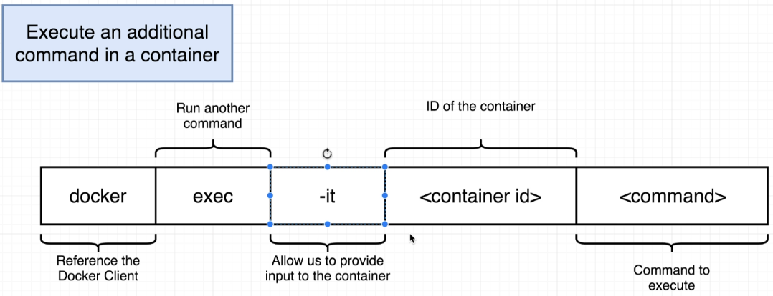

PS C:\Users\thisi> **docker ps**

CONTAINER ID IMAGE COMMAND CREATED STATUS PORTS NAMES

e60e9c1364d6 redis "docker-entrypoint.s…" 7 minutes ago Up 7 minutes 6379/tcp mystifying_hoover

0876edd8a5aa ubuntu "/bin/bash" 41 minutes ago Up 41 minutes brave_tereshkova

3267b93148b2 ubuntu "/bin/bash" 42 minutes ago Up 42 minutes nostalgic_pare

266d67f9cd83 busybox "ping google.com" 4 hours ago Up 4 hours loving_mclaren

8621e0b093b1 busybox "ping google.com" 4 hours ago Up 4 hours nice_agnesi

PS C:\Users\thisi> docker exec -it e60e9c1364d6 redis-cli

127.0.0.1:6379> **set myvalue 5**

OK

127.0.0.1:6379> **get myvalue**

"5"

127.0.0.1:6379>

PS C:\Users\thisi> **docker ps**

CONTAINER ID IMAGE COMMAND CREATED STATUS PORTS NAMES

e60e9c1364d6 redis "docker-entrypoint.s…" 7 minutes ago Up 7 minutes 6379/tcp mystifying_hoover

0876edd8a5aa ubuntu "/bin/bash" 41 minutes ago Up 41 minutes brave_tereshkova

3267b93148b2 ubuntu "/bin/bash" 42 minutes ago Up 42 minutes nostalgic_pare

266d67f9cd83 busybox "ping google.com" 4 hours ago Up 4 hours loving_mclaren

8621e0b093b1 busybox "ping google.com" 4 hours ago Up 4 hours nice_agnesi

PS C:\Users\thisi> **docker exec -it e60e9c1364d6 redis-cli**

127.0.0.1:6379> **set myvalue 5**

OK

127.0.0.1:6379> **get myvalue**

"5"

127.0.0.1:6379>

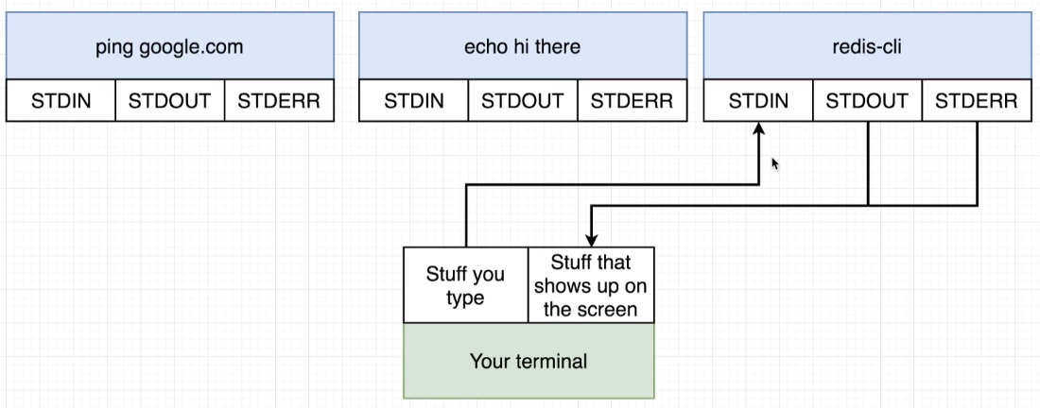

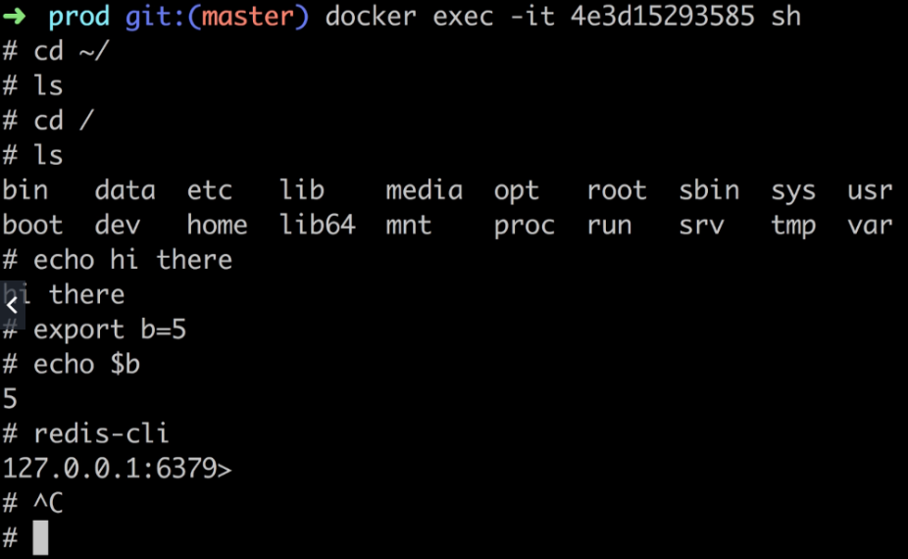

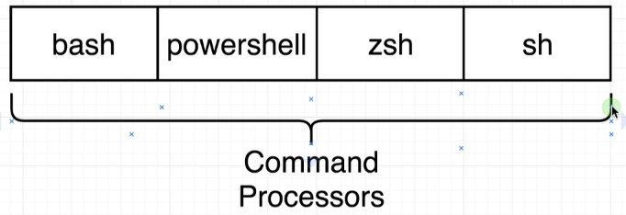

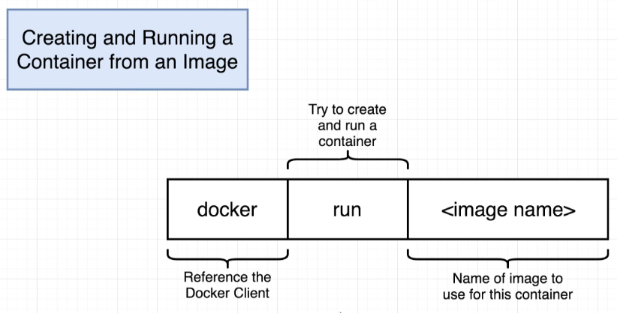

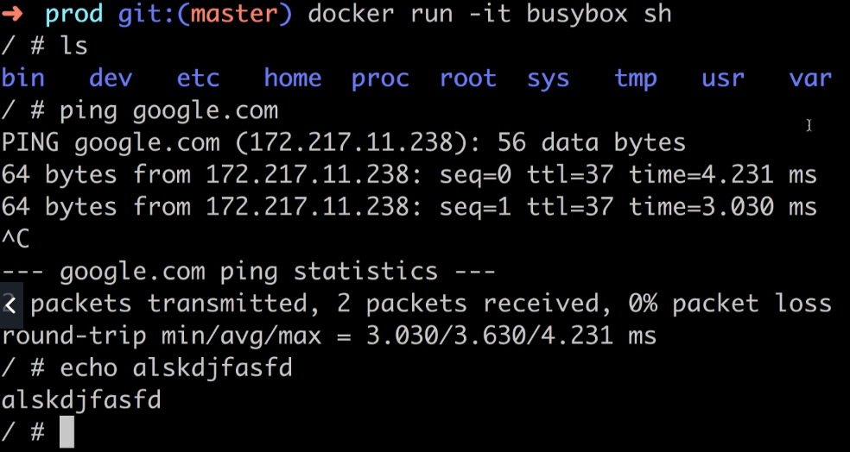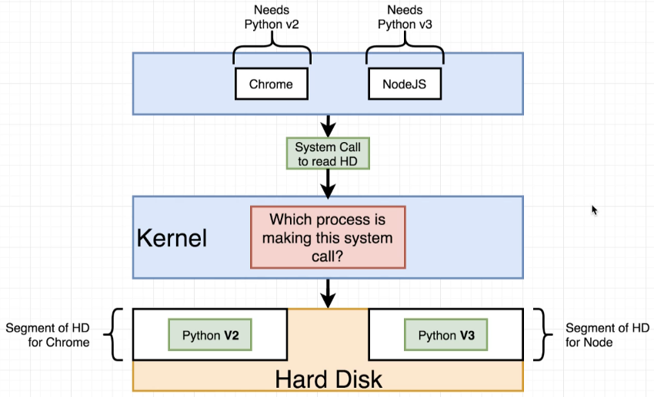

**Section 3: Building Custom  
Images Through Docker Server**

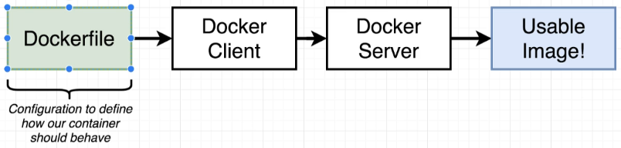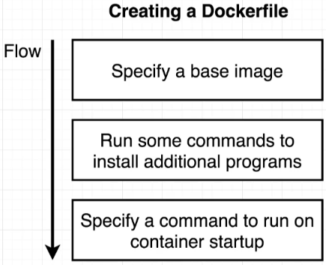

Buildkit for Docker Desktop v2.4.0+ and Edge

Some students, depending on the release channel they are on, will now have "Buildkit" enabled by default. If so, you will notice a slightly different output in your terminal when building from a Dockerfile.

The main difference for students will be the final step in the build process. As shown in the lecture the last step would say:

1. ---> fc60771eaa08
2. Successfully Built fc60771eaa08

Now, with Buildkit, the final step would say:

1. => => exporting layers
2. 0.0s => => writing image sha256:ee59c34ada9890ca09145cc88ccb25d32b677fc3b61e921  0.0s

Both ***fc60771eaa08****and****ee59c34ada9890ca09145cc88ccb25d32b677fc3b61e921***are the resulting image ID's that you would use to run a container.

eg:

1. docker run fc60771eaa08

or

1. docker run ee59c34ada9890ca09145cc88ccb25d32b677fc3b61e921

If you wish to disable the Buildkit feature so that you can more accurately follow along with the course, do the following:

1. Click the Docker Icon your systray
2. Select "Preferences"
3. Select "Docker Engine"
4. Change buildkit from **true** to **false**
   1. {
   2. "features": {
   3. "buildkit": false
   4. },
   5. "experimental": false
   6. }
5. Apply and Restart.

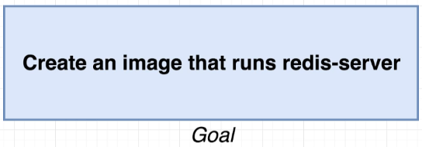

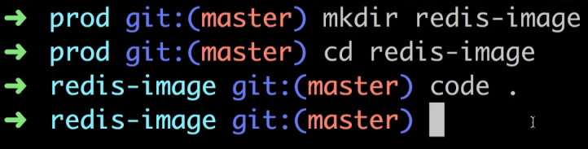

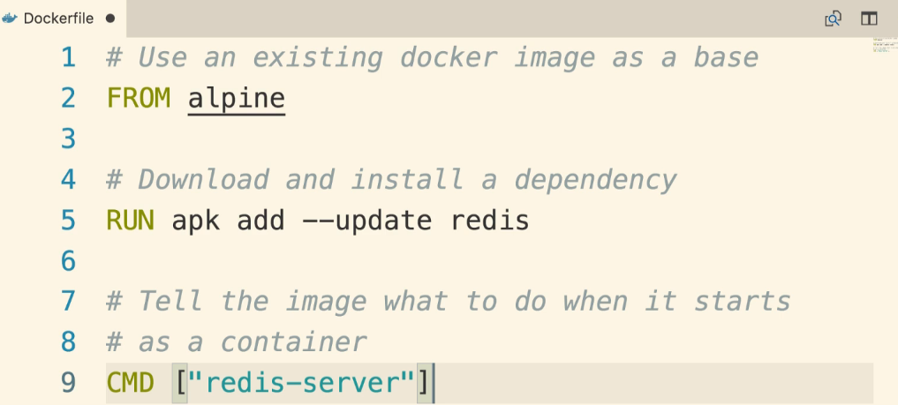

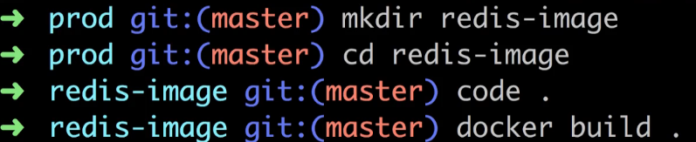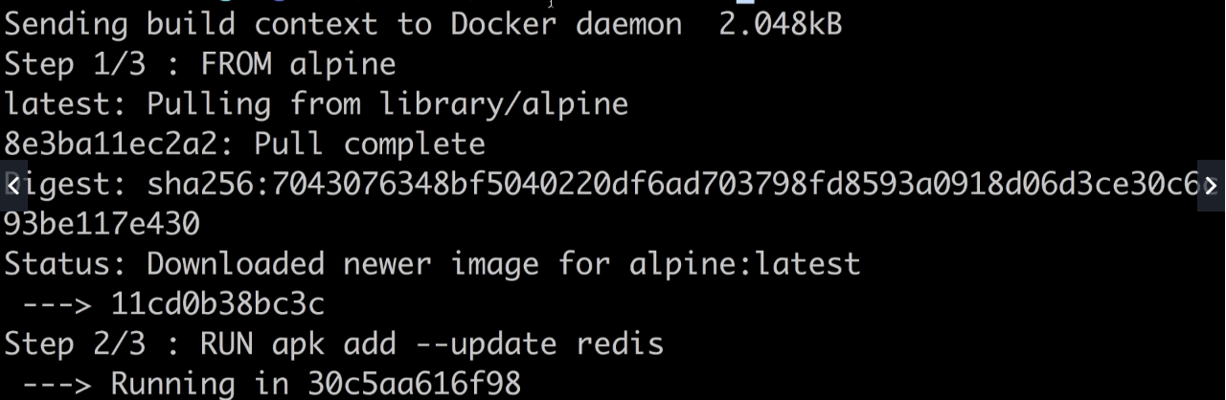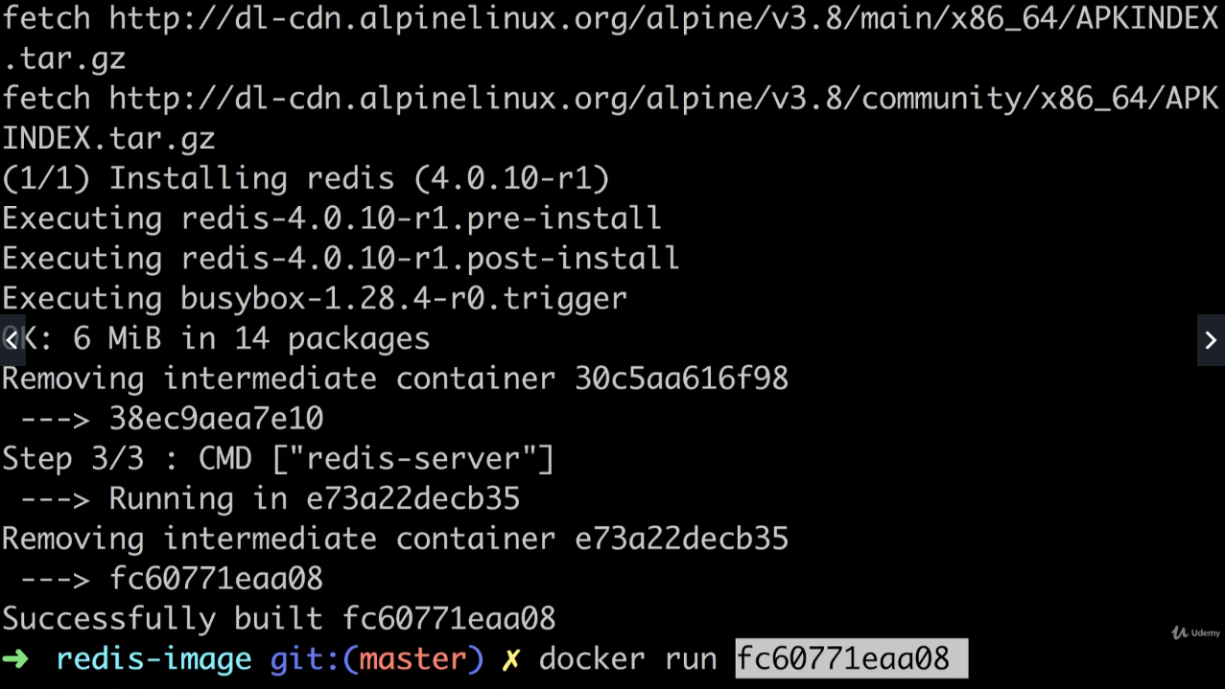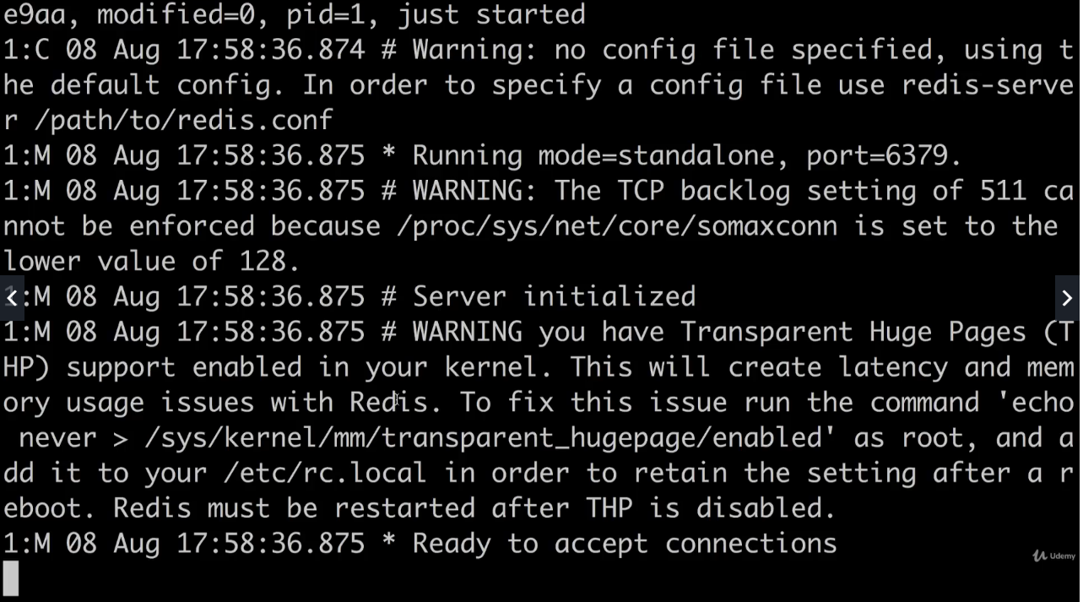

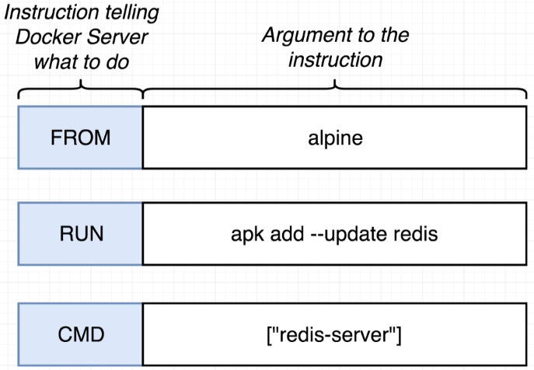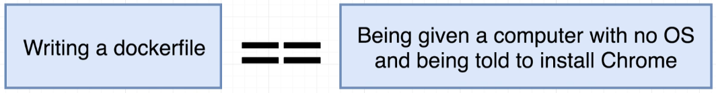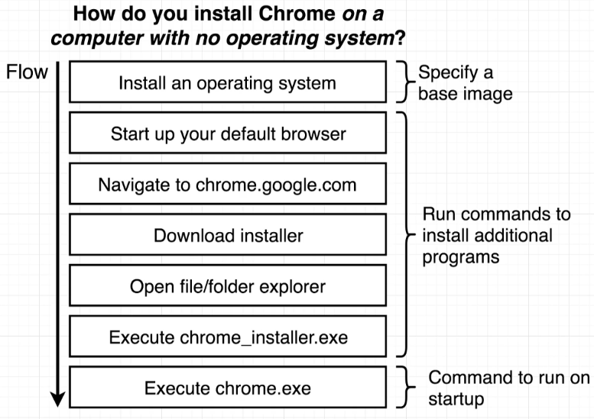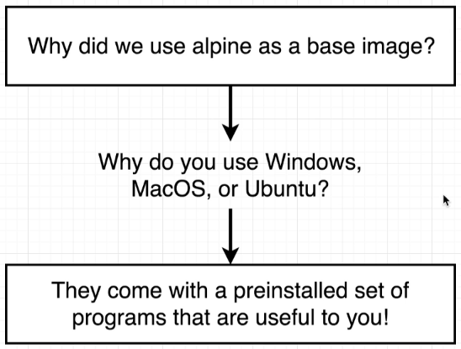

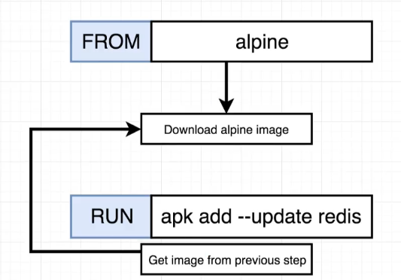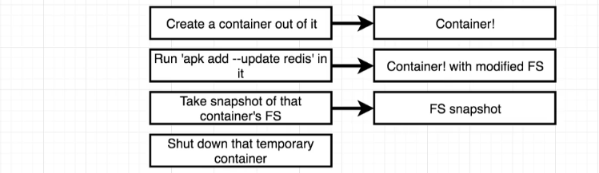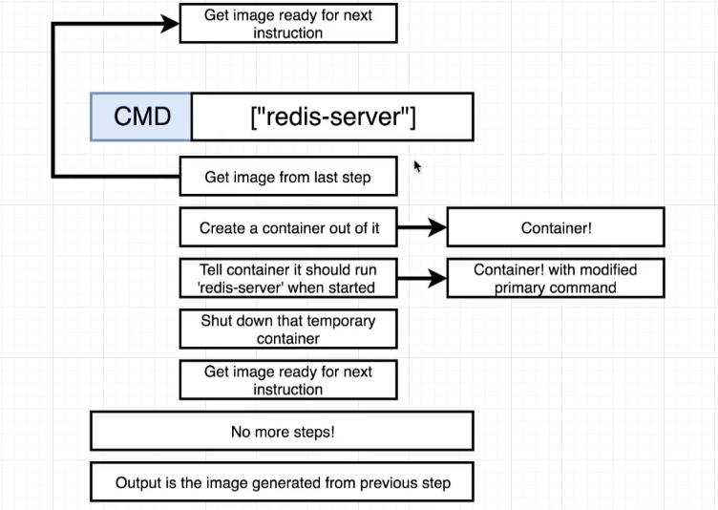

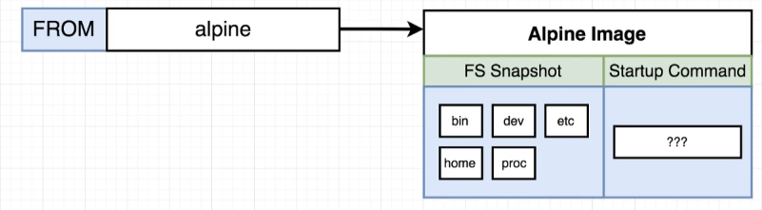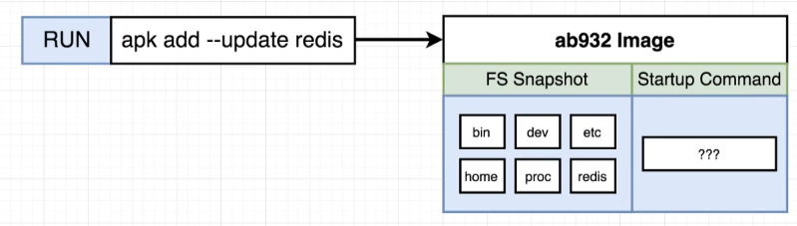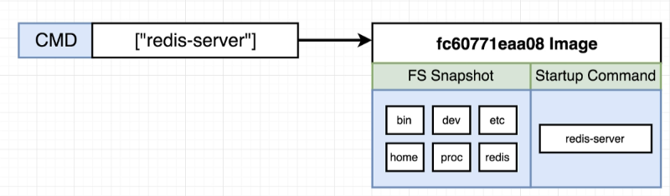

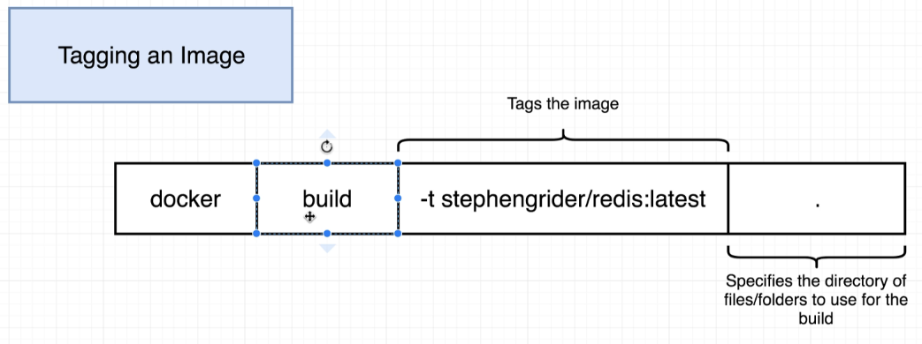 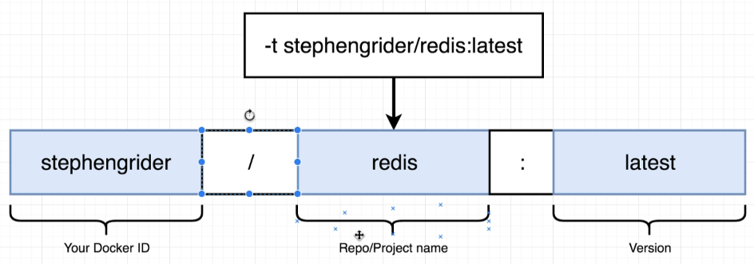

**docker build -t stephengrider/redis: latest .**

**…**

**docker run stephengrider/redis**

Quick Note for Windows Users

In the upcoming lecture, we will be running a command to create a new image using docker commit with this command:

docker commit -c 'CMD ["redis-server"]' CONTAINERID

If you are a Windows user you may get an error like "**/bin/sh: [redis-server]: not found"**or**"No Such Container"**

Instead, try running the command like this:

docker commit -c **"CMD 'redis-server'"** CONTAINERID

**39. Manual Image Generation with   
Docker Commit**

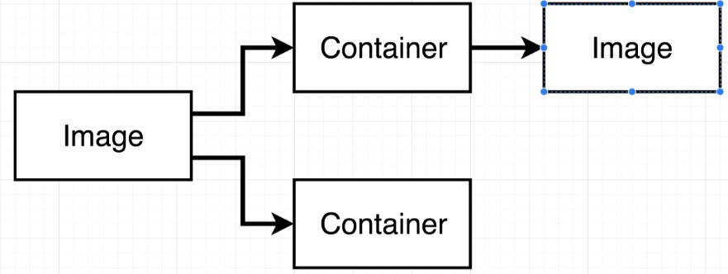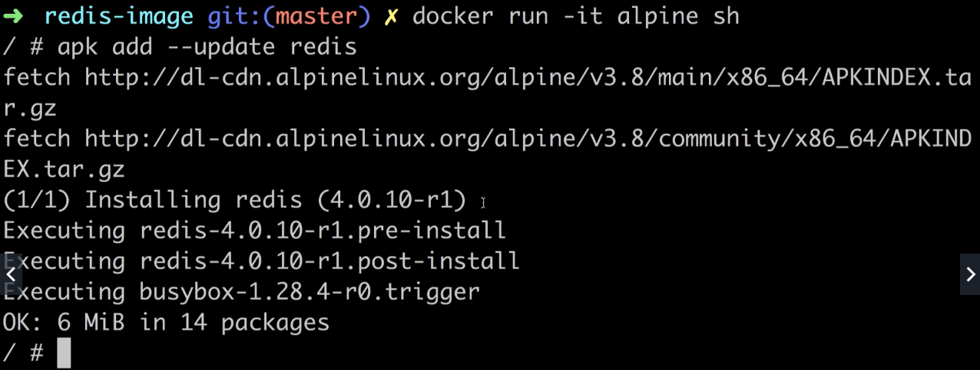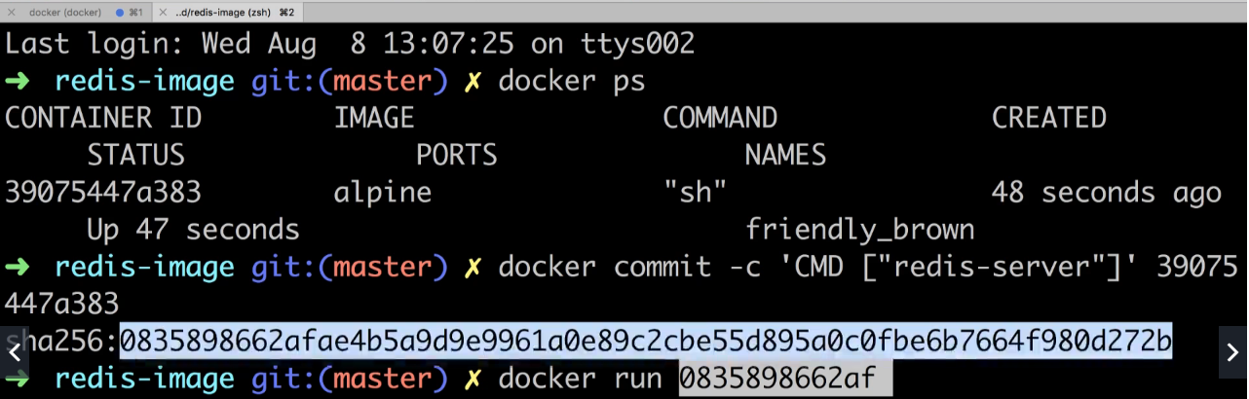

40. Project Outline

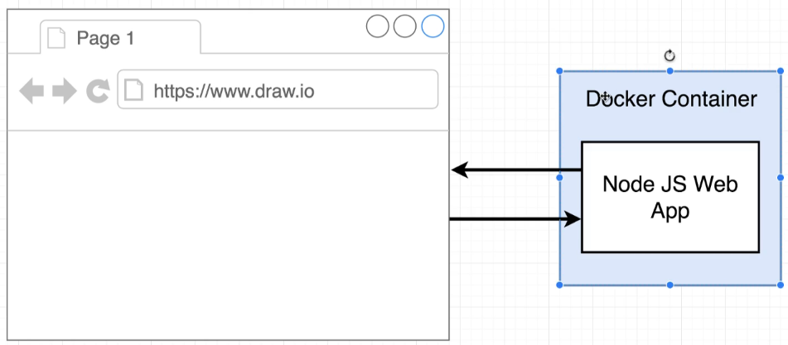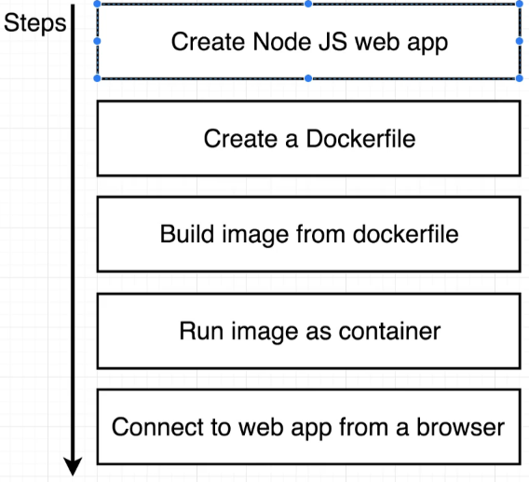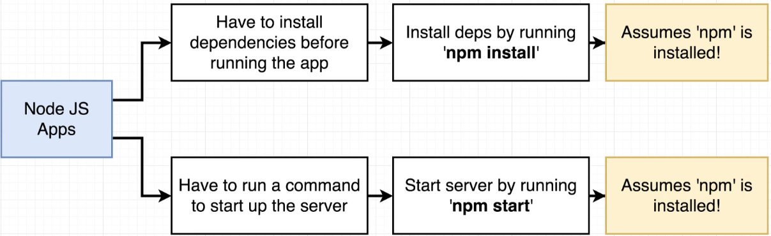

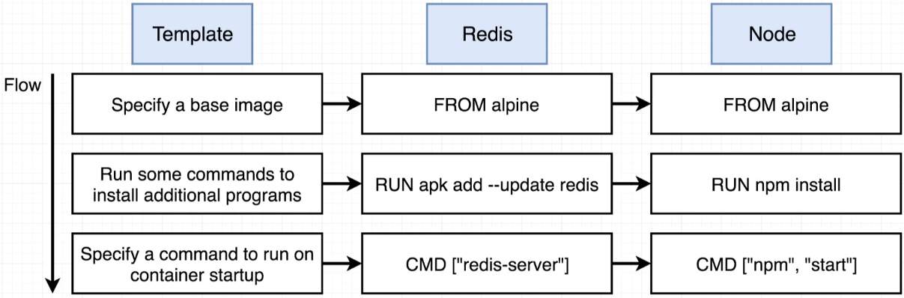

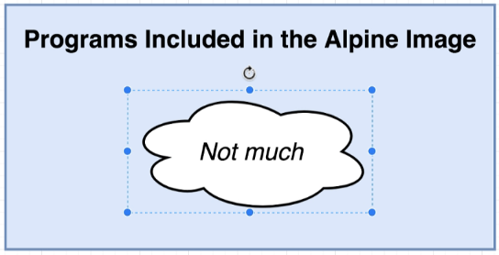 npm is not installed

**46. Hub.docker.com 🡪 explore**

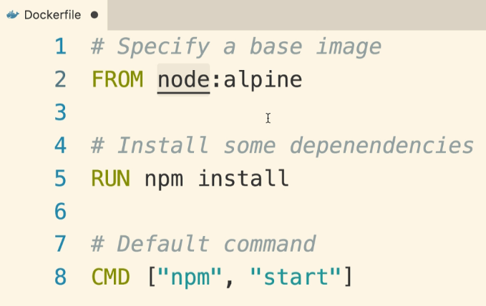 json not found

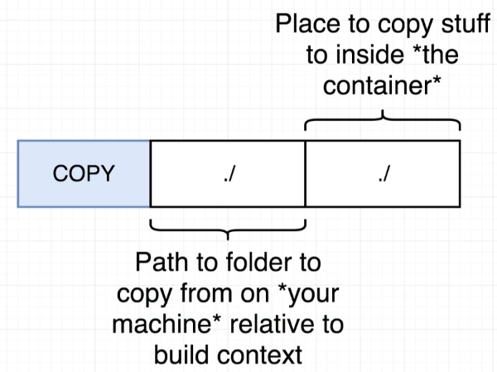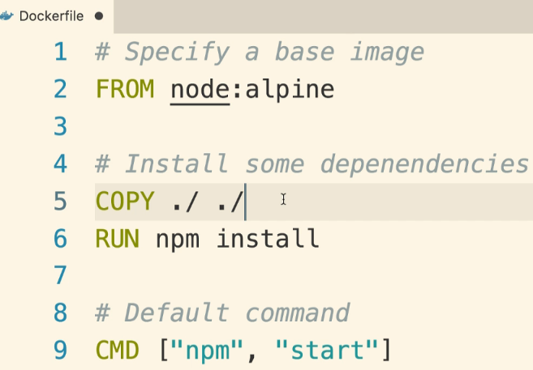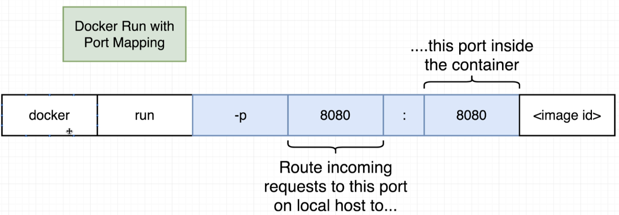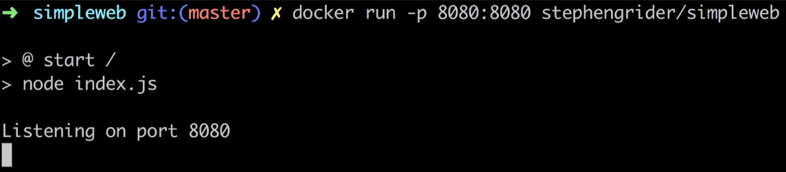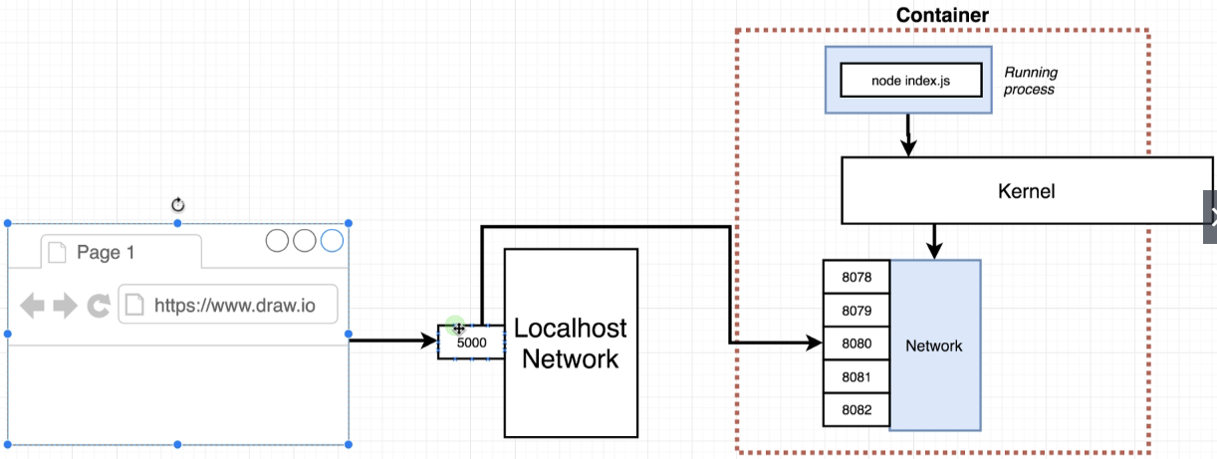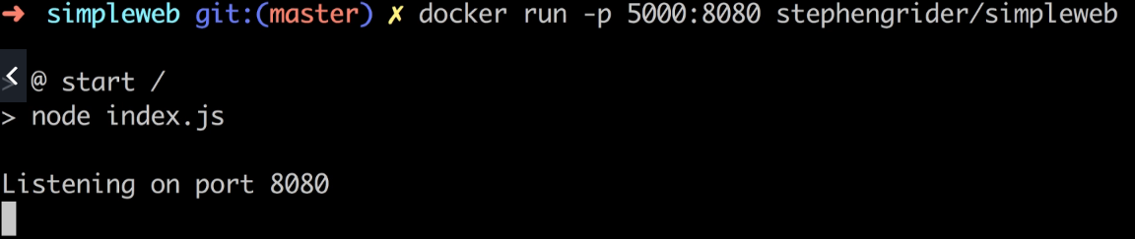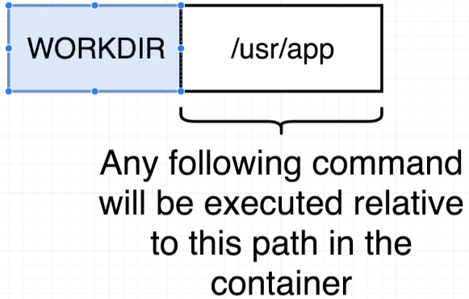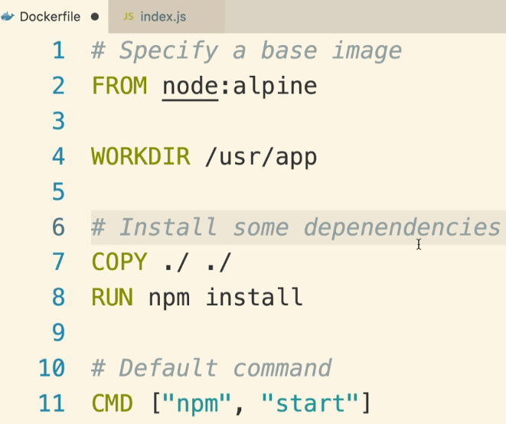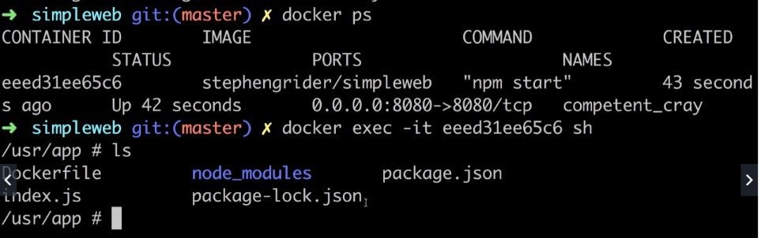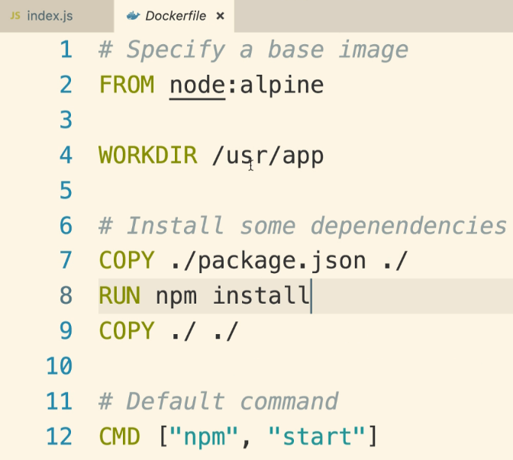

**Section 5: Docker Compose  
with Multiple Local Containers**

**Section 6: Creating a  
Production-Grade Workflow**

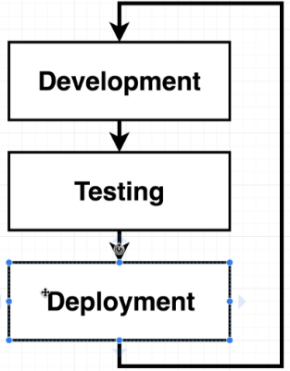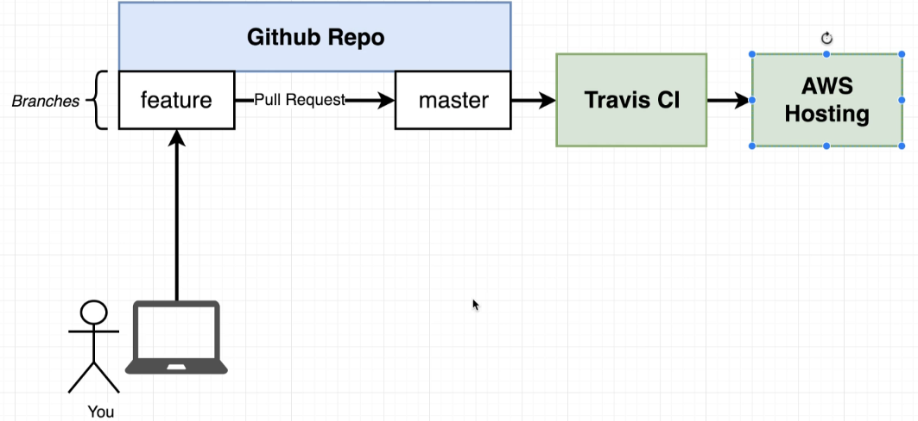

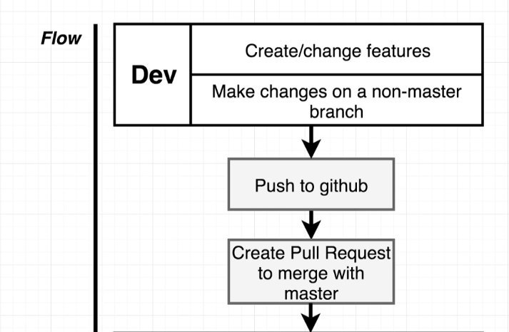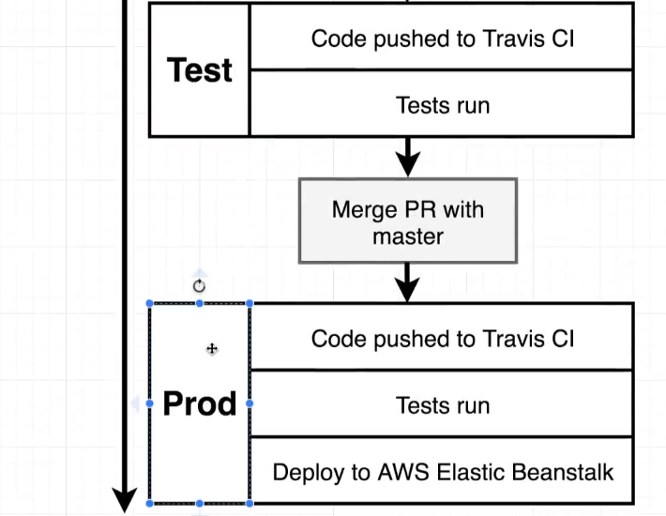

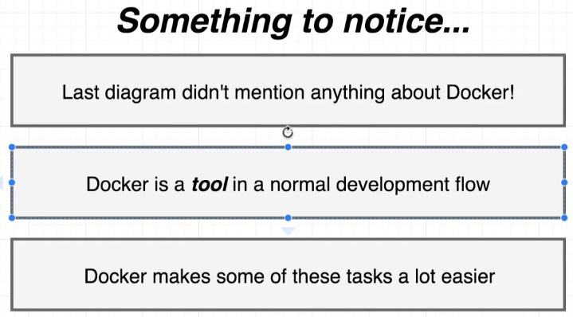

[**https://nodejs.org/en/download/**](https://nodejs.org/en/download/)

**install node.js**

Create React App Generation

**updated 8-4-2020**

In the next lecture, Stephen will be going over how to install Create React App globally and generate the application. This method of generating a React project is no longer recommended.

**Instead of this:**

npm install -g create-react-app

create-react-app frontend

**We need to run this command:**

npx create-react-app frontend

**Documentation:**

<https://create-react-app.dev/docs/getting-started#npx>

*If you've previously installed create-react-app globally via npm install -g create-react-app, we recommend you uninstall the package using npm uninstall -g create-react-app to ensure that npx always uses the latest version.*

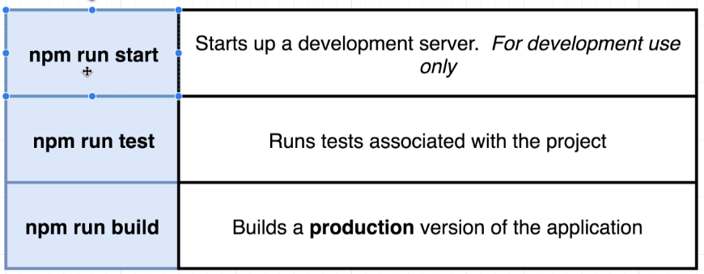

72 - React App Exits Immediately with Docker Run Command

**3-22-2020**

Due to a recent update in the Create React App library, we will need to change how we start our containers.

In the upcoming lecture, you'll need to add the -it flag to run the container in interactive mode:

docker run -it -p 3000:3000 IMAGE_ID

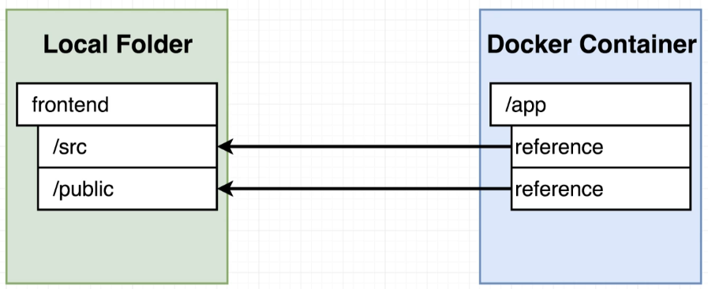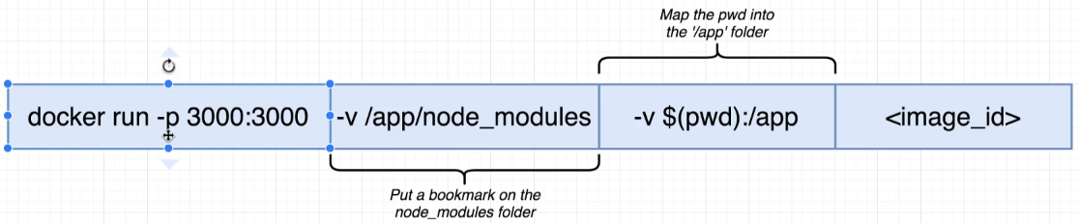

75

Windows not Detecting Changes - Update

**updated 4-14-2020**

This note will cover a variety of different fixes for volumes issues and file watchers not updating changes. The example commands have been tested and confirmed to be accurate as of this writing. Each terminal will require a slightly different syntax for the pwd (present working directory) variable.

**Windows Home with Docker Toolbox**

1. Pass the container the environment variable with fix directly in the docker run command (recommended):

-e CHOKIDAR_USEPOLLING=true

or

2. Create a **.env** file in the project root with the following inside of it:

CHOKIDAR_USEPOLLING=true

Working example commands for each terminal (be sure to run these commands in the root of your project directory)

**Docker Quickstart (recommended)**

docker run -it -p 3000:3000 -v /app/node_modules -v ${PWD}:/app -e CHOKIDAR_USEPOLLING=true IMAGE_ID

**GitBash**

winpty docker run -it -p 3000:3000 -v /app/node_modules -v "/$(PWD)":/app -e CHOKIDAR_USEPOLLING=true IMAGE_ID

**PowerShell**

docker run -it -p 3000:3000 -v /app/node_modules -v /c/Users/username/frontend:/app -e CHOKIDAR_USEPOLLING=true IMAGE_ID

Note: Currently, using the full path to your project directory is the only thing that seems to properly mount the volume. Please remember to replace your current working directory with what is shown in the command above.

**VirtualBox Folder Sharing**

By default, VirtualBox will share the C:\Users directory. If you are using an external or network drive or some other drive on your machine such as D:\ or F:\ it will not be shared and your volumes not be mounted properly.

Please make sure that the drive you are using has been shared by opening VirtualBox and clicking on "Settings", then "Shared Folders". The drive should be listed like below:

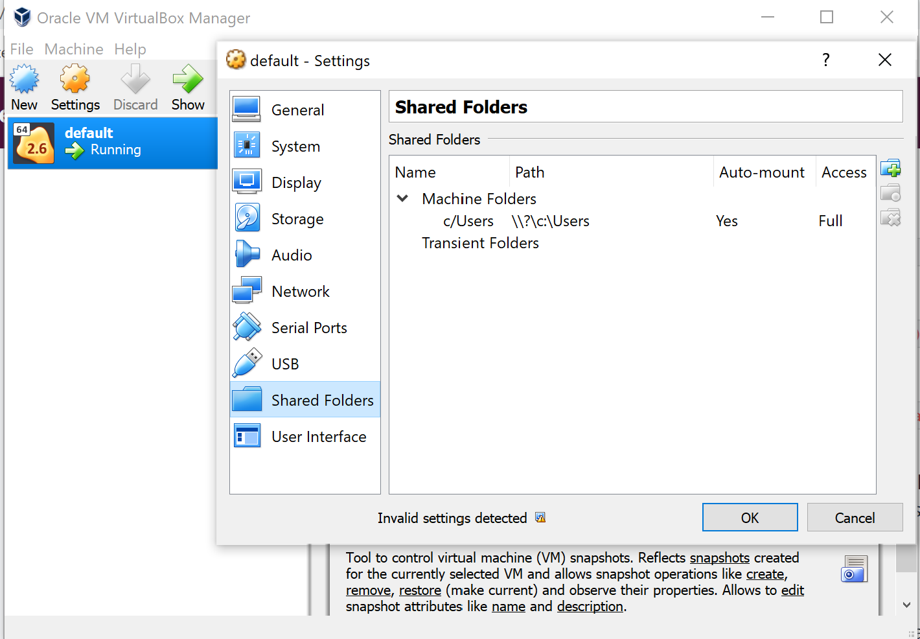

**Windows Defender, Firewalls and Anti-Virus**

Any of these services could possibly conflict with the volume mounting. When in doubt, disable each service one by one to see if the volumes begin working correctly.

**Windows Pro with Docker Desktop**

If you are using Windows and Docker Desktop v2.2 or higher and the latest Create React App v3.4.1, most of the file watching issues have been resolved. If you are using a version of Docker Desktop older than version v2.2 you should update to the latest version.

Working example commands for each terminal (be sure to run these commands in the root of your project directory)

**GitBash**

winpty docker run -it -p 3000:3000 -v /app/node_modules -v "/$(PWD)":/app IMAGE_ID

**PowerShell**

docker run -it -p 3000:3000 -v /app/node_modules -v ${pwd}:/app IMAGE_ID

**Docker Desktop File Sharing**

By default, your C:\ will be shared with Docker Desktop for volume mounting. If you are using an external or network drive or some other drive on your machine such as D:\ or F:\ it will not be shared and your volumes not be mounted properly.

Please make sure that the drive you are using has been shared by clicking Docker icon in the systray. Click "Settings", then "Resources" and finally "File Sharing". The drive should be listed like below:

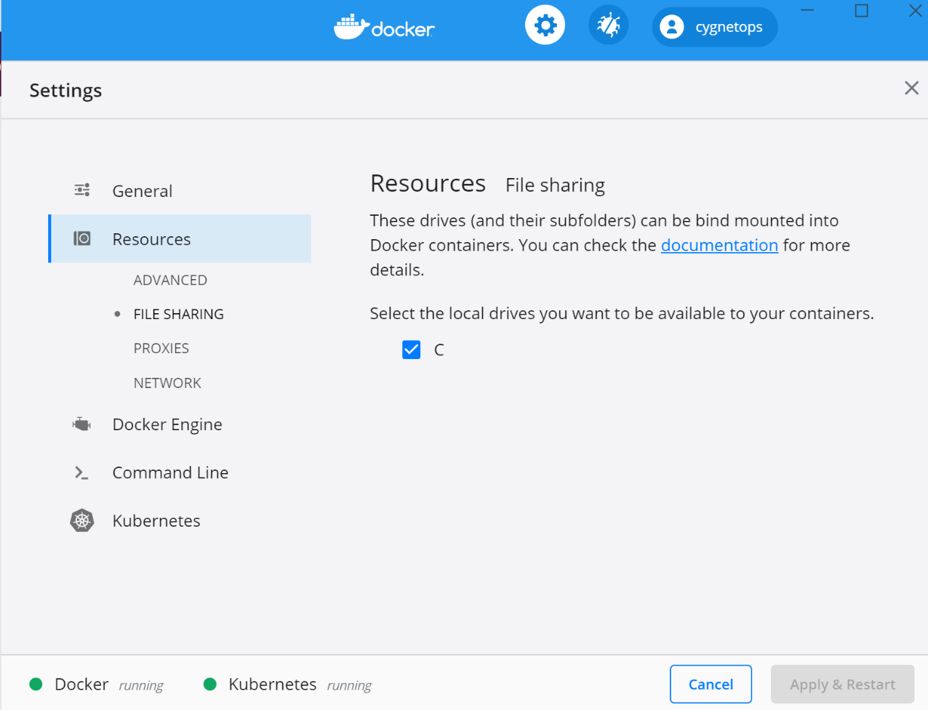

**Windows Defender, Firewalls and Anti-Virus**

Any of these services could possibly conflict with the volume mounting. When in doubt, disable each service one by one to see if the volumes begin working correctly.

77

React App Exited With Code 0

**4-1-2020**

Recently, a bug was introduced with the latest Create React App version that is causing the React app to exit when starting with Docker Compose.

To Resolve this:

**Add stdin_open property to your docker-compose.yml file**

1. web:
2. stdin_open: true

Make sure you rebuild your containers after making this change with  docker-compose down && docker-compose up --build

<https://github.com/facebook/create-react-app/issues/8688>

<https://stackoverflow.com/questions/60790696/react-scripts-start-exiting-in-docker-foreground-cmd>

88

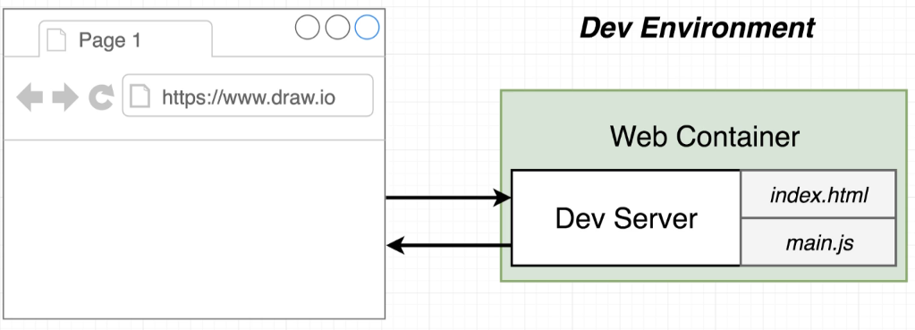

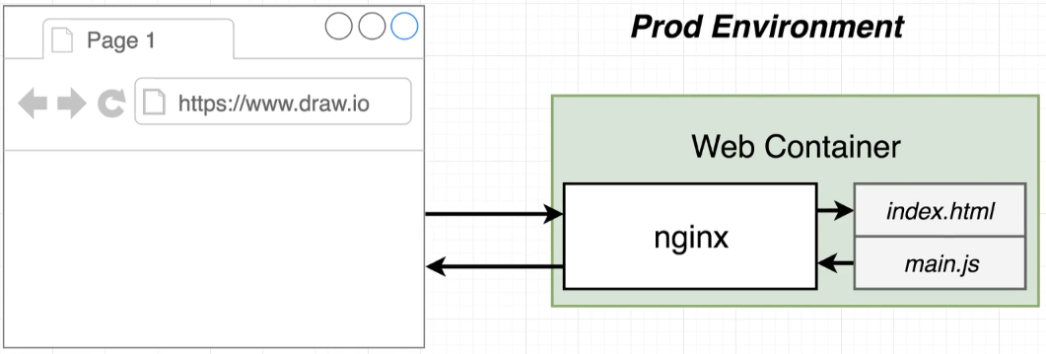

Nginx is a web server

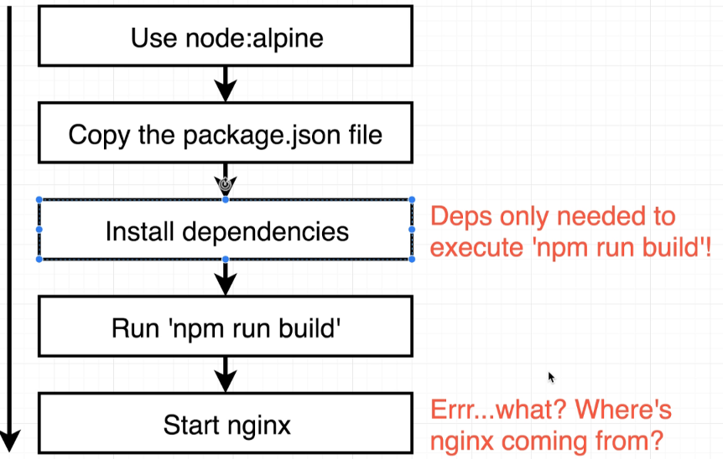

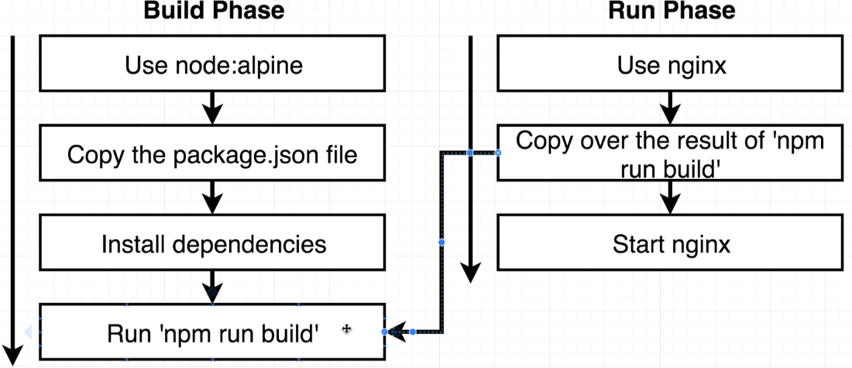

Section 7

